**Pizza Sales Project SQL Queries**

**Over-viewing the data**

SELECT * FROM pizza_sales

**KPI’s Requirement:**

1. **Total Revenue**

SELECT CAST(SUM(total_price) AS DECIMAL(10,2)) AS Total_Revenue FROM pizza_sales

*OUTPUT:*

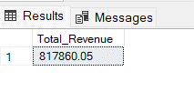

1. **Average Order Value**

SELECT CAST(SUM(total_price) / COUNT(DISTINCT order_id) AS DECIMAL(10,2)) AS Average_Order_Value FROM pizza_sales

*OUTPUT:*

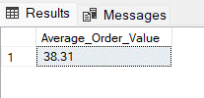

1. **Total Pizzas Sold**

SELECT SUM(quantity) AS Total_Pizzas_Sold FROM pizza_sales

*OUTPUT:*

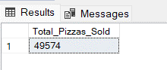

1. **Total Orders**

SELECT COUNT(DISTINCT order_id) AS Total_Orders FROM pizza_sales

*OUTPUT:*

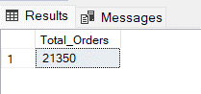

1. **Average Pizzas Per Order**

SELECT CAST(CAST(SUM(quantity) AS DECIMAL(10,2)) / CAST(COUNT(DISTINCT order_id) AS DECIMAL(10,2)) AS DECIMAL(10,2)) AS Average_Pizzas_Per_Order FROM pizza_sales

*OUTPUT:*

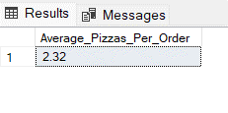

**Business Insights Report:**

1. **Daily Trend for Total Orders**

SELECT DATENAME(DW,order_date) AS Day, COUNT(DISTINCT order_id) AS Total_Orders FROM pizza_sales GROUP BY DATENAME(DW,order_date), DATEPART(DW,order_date) ORDER BY DATEPART(DW,order_date)

*OUTPUT:*

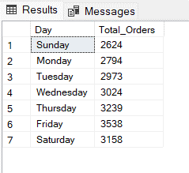

1. **Monthly Trend for Total Orders**

SELECT DATENAME(MONTH,order_date) as MONTH, COUNT(DISTINCT order_id) as Total_Orders FROM pizza_sales

GROUP BY DATENAME(MONTH,order_date), DATEPART(MONTH,order_date) ORDER BY DATEPART(MONTH,order_date)

*OUTPUT:*

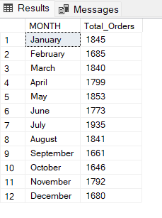

1. **Percentage of Sales by Pizza Category**

SELECT pizza_category AS Pizza_Category, CAST(SUM(total_price) AS DECIMAL(10,2)) AS Total_Sales, CAST(SUM(total_price) * 100 /(SELECT SUM(total_price) FROM pizza_sales) AS DECIMAL(10,2)) AS Percentage_of_Sales FROM pizza_sales GROUP BY pizza_category ORDER BY Percentage_of_Sales

*OUTPUT:*

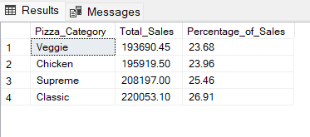

1. **Percentage of Sales by Pizza Size**

SELECT pizza_size AS Pizza_Size,CAST(SUM(total_price) AS DECIMAL(10,2)) AS Total_Sales, CAST(SUM(total_price) * 100 / (SELECT SUM(total_price) FROM pizza_sales) AS DECIMAL(10,2)) AS Percentage_of_Sales FROM pizza_sales

GROUP BY pizza_size ORDER BY Percentage_of_Sales DESC

*OUTPUT:*

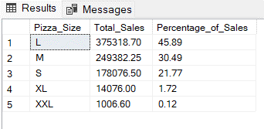

1. **Total Pizzas Sold by Pizza Category**

SELECT pizza_category AS Pizza_Category, SUM(quantity) as Total_Pizzas_Sold FROM pizza_sales

GROUP BY pizza_category ORDER BY Total_Pizzas_Sold DESC

*OUTPUT:*

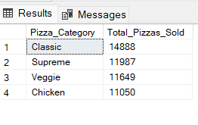

1. **Top 5 Pizzas by Total Revenue**

SELECT TOP 5 pizza_name as Pizza_Name, CAST(SUM(total_price) AS DECIMAL(10,2)) AS Total_Revenue

FROM pizza_sales GROUP BY pizza_name ORDER BY Total_Revenue DESC

*OUTPUT:*

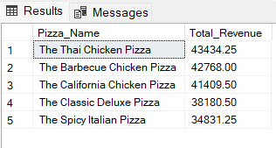

**Top 5 Pizzas by Total Quantity**

SELECT TOP 5 pizza_name as Pizza_Name, SUM(quantity) AS Total_Quantity FROM pizza_sales

GROUP BY pizza_name ORDER BY Total_Quantity DESC

*OUTPUT:*

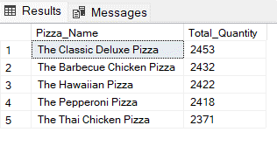

**Top 5 Pizzas by Total Orders**

SELECT TOP 5 pizza_name as Pizza_Name, COUNT(DISTINCT order_id) as Total_Orders FROM pizza_sales

GROUP BY pizza_name ORDER BY Total_Orders DESC

*OUTPUT:*

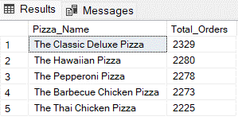

1. **Bottom 5 Pizzas by Total Revenue**

SELECT TOP 5 pizza_name as Pizza_Name, CAST(SUM(total_price) AS DECIMAL(10,2)) AS Total_Revenue

FROM pizza_sales GROUP BY pizza_name ORDER BY Total_Revenue

*OUTPUT:*

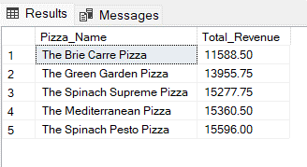

**Bottom 5 Pizzas by Total Quantity**

SELECT TOP 5 pizza_name as Pizza_Name, SUM(quantity) AS Total_Quantity FROM pizza_sales GROUP BY pizza_name ORDER BY Total_Quantity

*OUTPUT:*

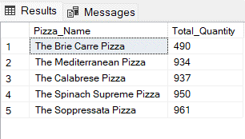

**Bottom 5 Pizzas by Total Orders**

SELECT TOP 5 pizza_name as Pizza_Name, COUNT(DISTINCT order_id) as Total_Orders FROM pizza_sales GROUP BY pizza_name ORDER BY Total_Orders

*OUTPUT:*

